Physics:
Rubber band powered car

Adam Castaneda
&
Dulce Contreras

For this project we wanted to build something that could show three types of motion: increasing speed, constant speed and slowing down or stopping.
Picture of the our car
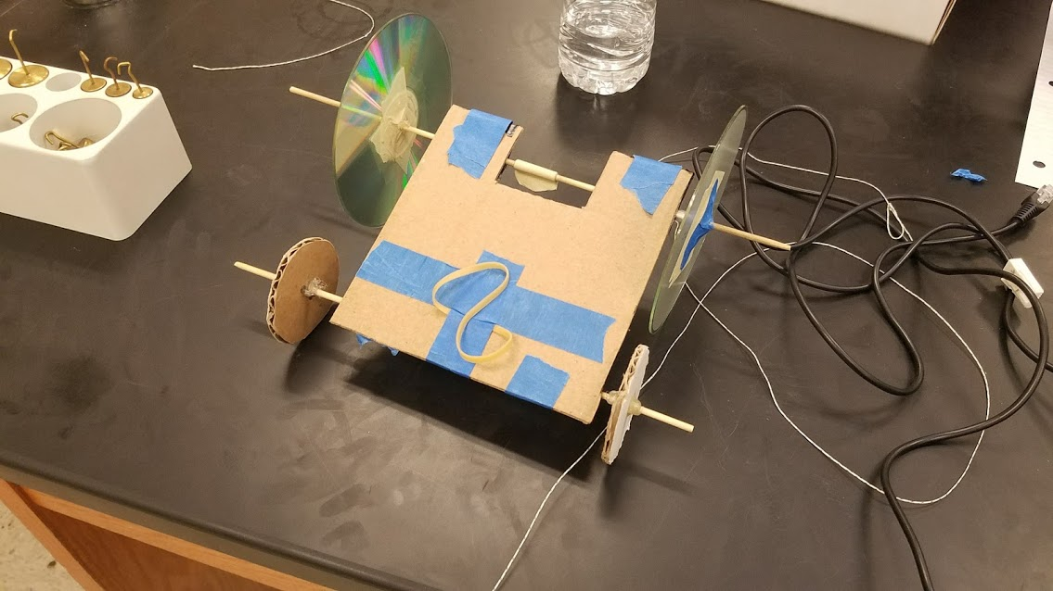
Force Sensor: (200g weight on car)
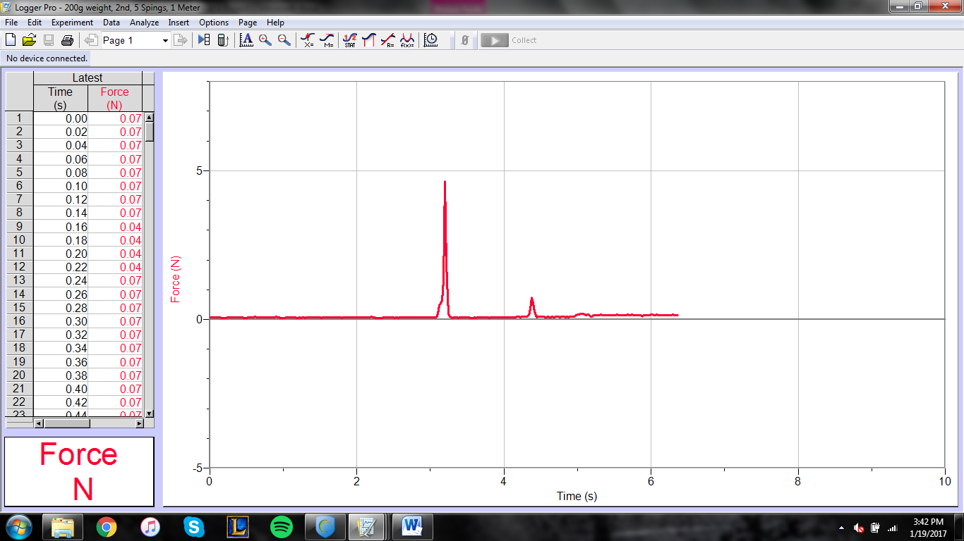
- For this trail the car was taped to a string that was 1 meter long and tied to the force sensor and it applied force on sensor once it reached 1 meter.
- A 200g weight was put on the car to see how weight would affect the force applied to the sensor.
- The car put a maximum force of 4.8N after accelerating for 1 meter and pulling on the force sensor.
(No weight)
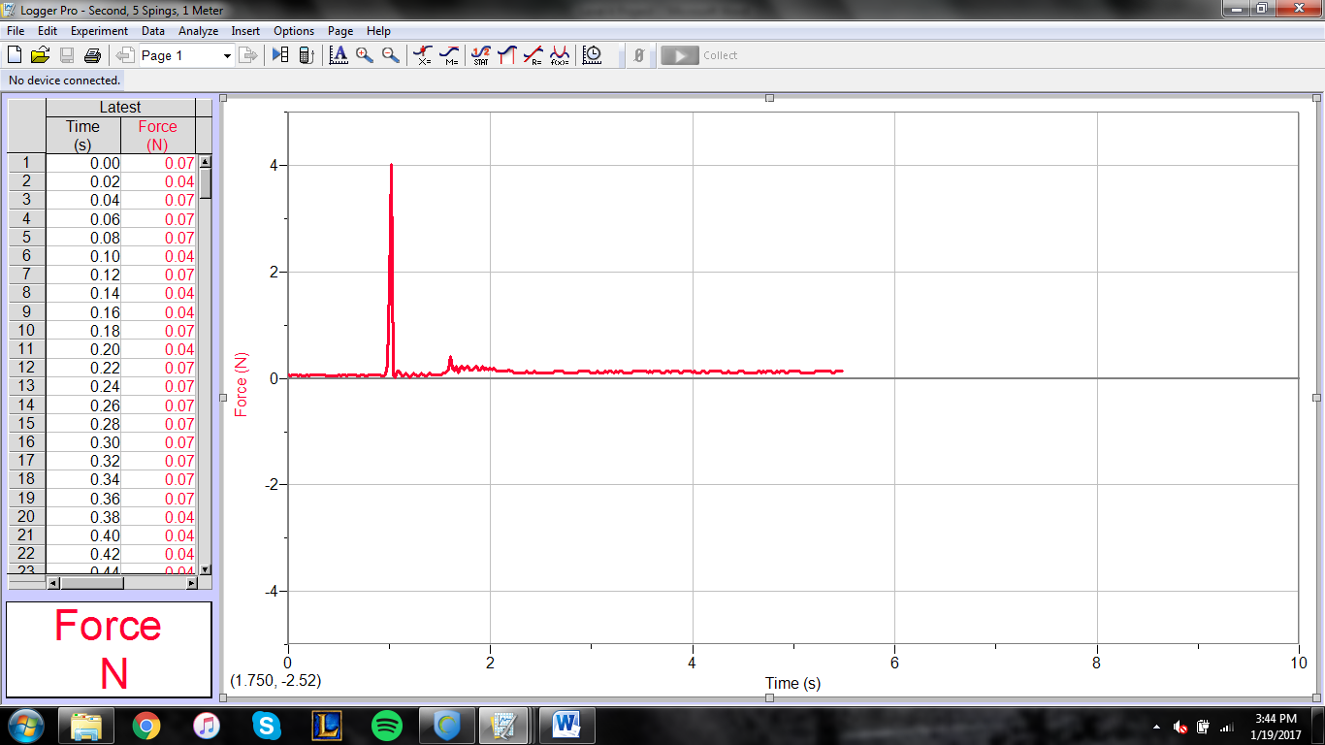
- For this trail the car was taped to a string that was 1 meter long and tied to the force sensor and it applied force on sensor once it reached 1 meter.
- The car put a maximum force of 4N after accelerating for 1 meter and pulling on the force sensor.
- Having less weight on the car seemed have produced less force acting on the sensor, than if it was weighted.
Motion Sensor: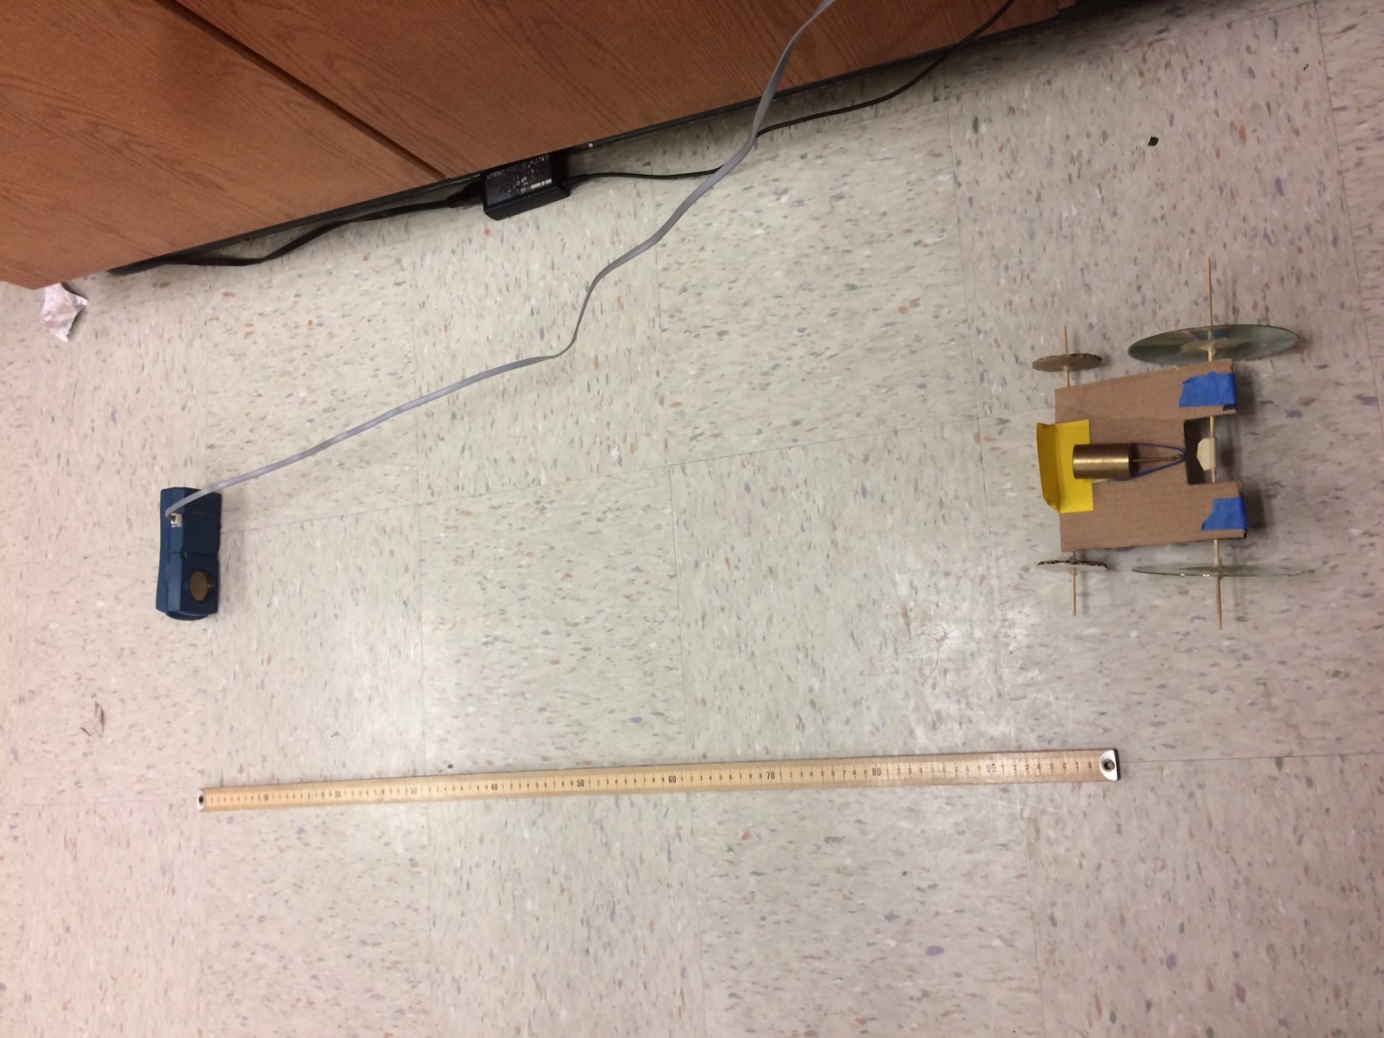
(200g on car) 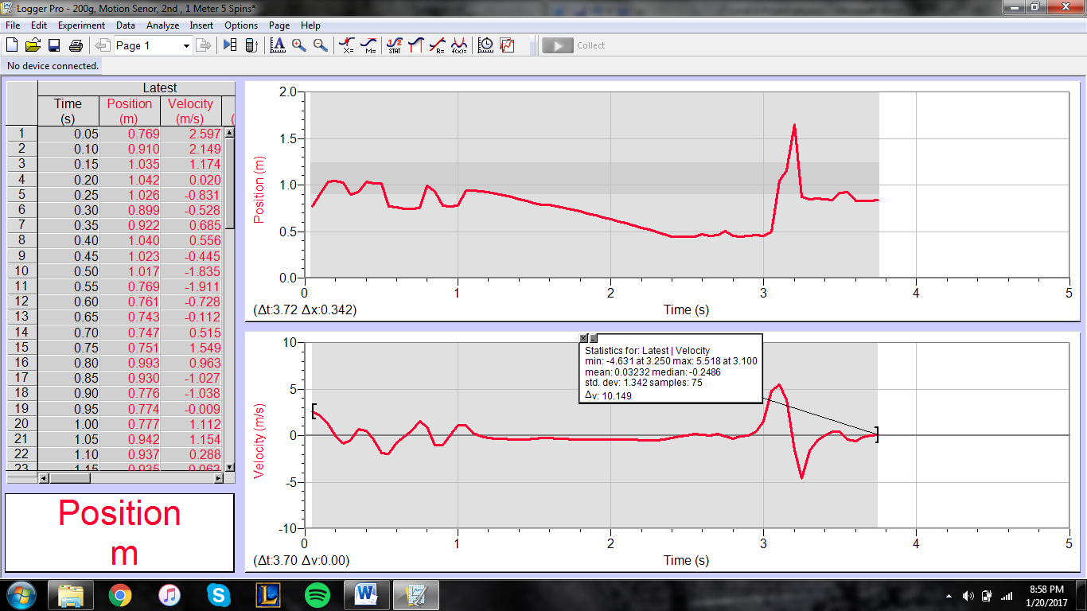
- For this trail we put a motion sensor 1 front of the car to test maximum velocity of the car.
- A 200g weight was placed on the car to see how weight would affect the car’s maximum velocity.
- The car reached a maximum velocity of 5.5 at 3.1s as shown in the graph above.

(No weight)
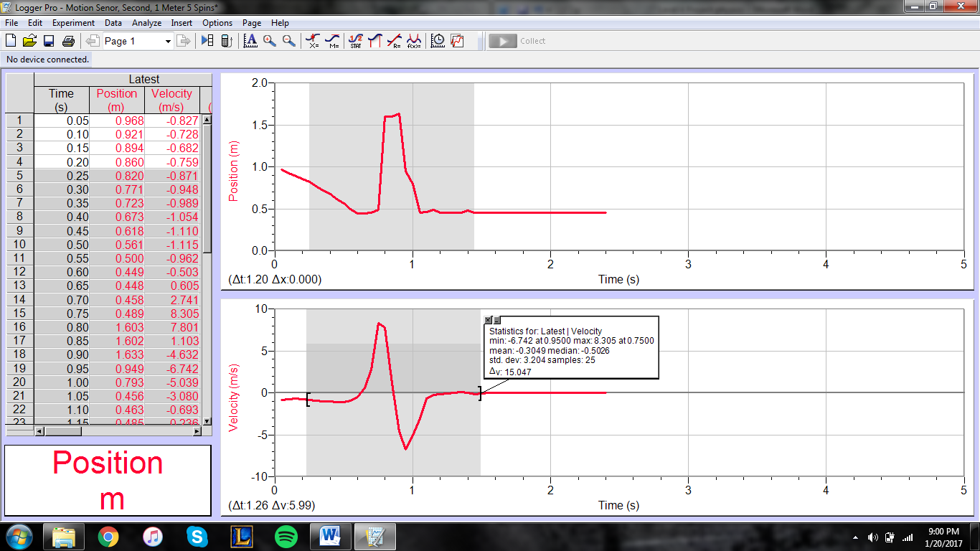
- For this trail we put a motion sensor in front of the car to test maximum velocity of the car.
- The car reached a maximum velocity of 8.3 at .7s as shown in the graph above.
- Based on both these graphs adding weight to the car affected its maximum velocity.
Photogate:
(Weighted 50g)
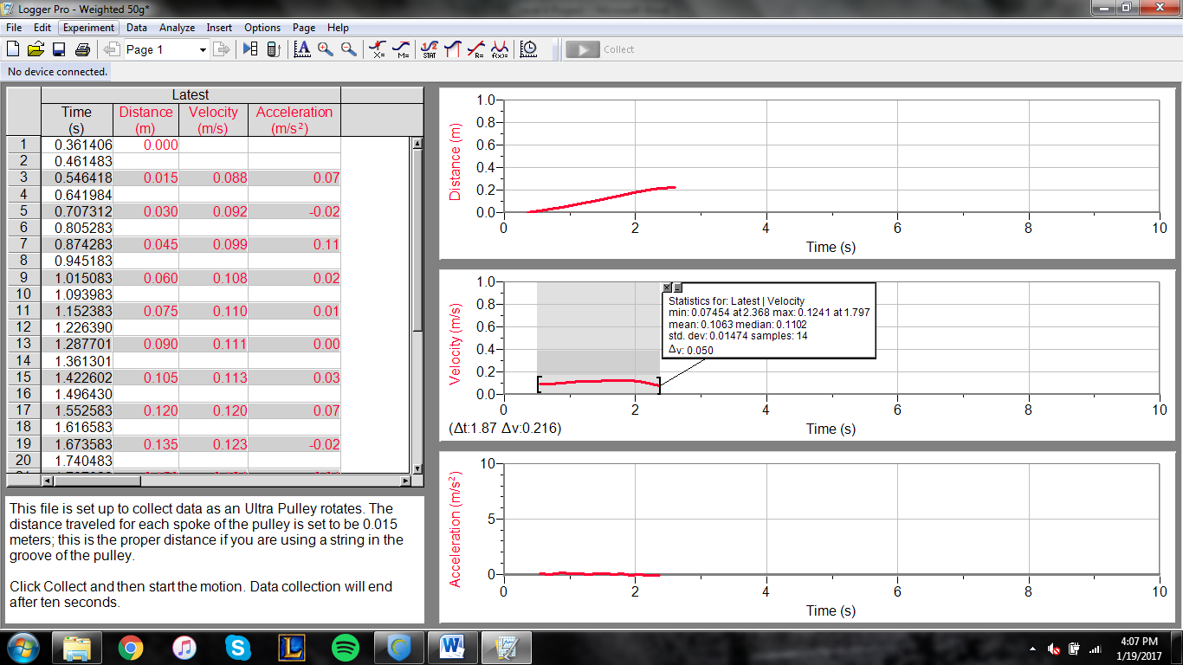
- For the photo gate we tested the velocity of the car.
- As for the velocity graph it shows that the velocity was at its maximum of 0.1241m/sec at 1.797sec and the minimum velocity was 0.07454 at the end of the trial as 2.368sec.
- It moved at a slower rate of velocity compared to the trial with the car with no weights on it.
- Also for the velocity graph, you can see visually that the velocity for the trial was almost pretty constant the whole turn.
- As a result on the distance graph right above of the velocity graph is visually shows that the car was gaining distance at a constant rate.
(No weight)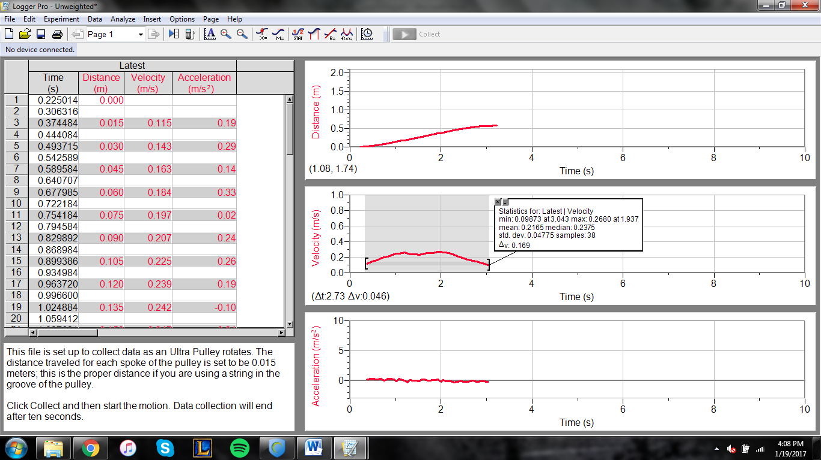
- This is the photo gate trial without any weights on the car.
- As shown in the velocity graph of the trail the maximum velocity of the care was 0.2680m/s at 1.937 sec. The cars velocity was at a minimum of 0.09873m/s at 3.043 sec.
- Compared to the trail of the car with a 50g weight, the velocity of the care was faster.
- This is the result of having less mass so the car has less inertia. With less inertia the car could get going faster than the car with weights.
- When we look at the velocity graph we see the velocity was also pretty constant but at a higher speed than the velocity of the weighted car.
- However, if we look at the distance graphs of both trials we can see that the distance was almost the same.
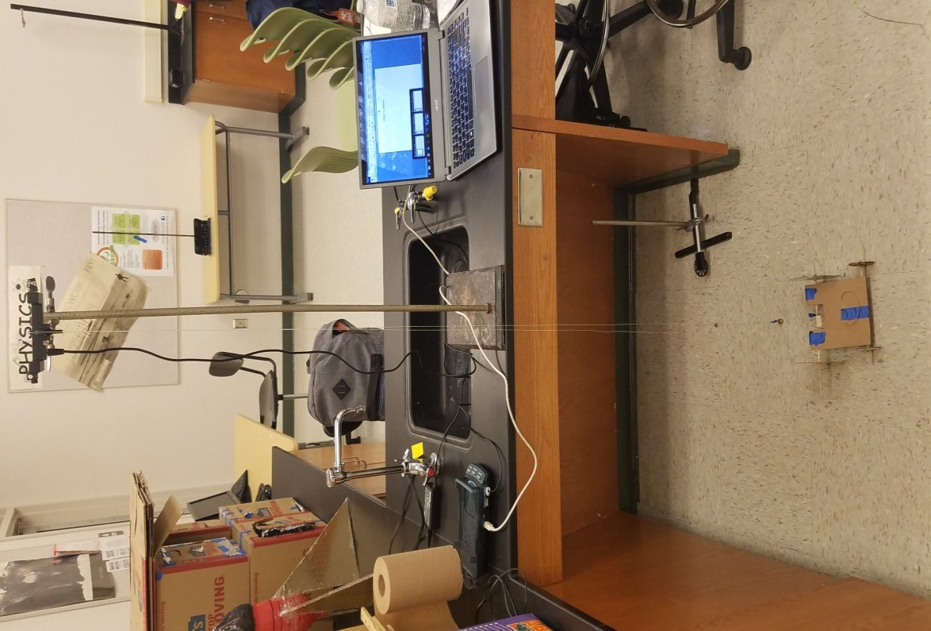
- To test the photo gate on the car we put the photo gate on a metal stand. Then we put a pulley in between the photo gate. We also tied one end of the string of the pulley onto the car and the other end of the string was attached to a weight. So. As the car moves the pulley will spin and it will break the beam of light that the photo gate has and record the data onto the graph in the computer.
Accelerometer:
(No weights)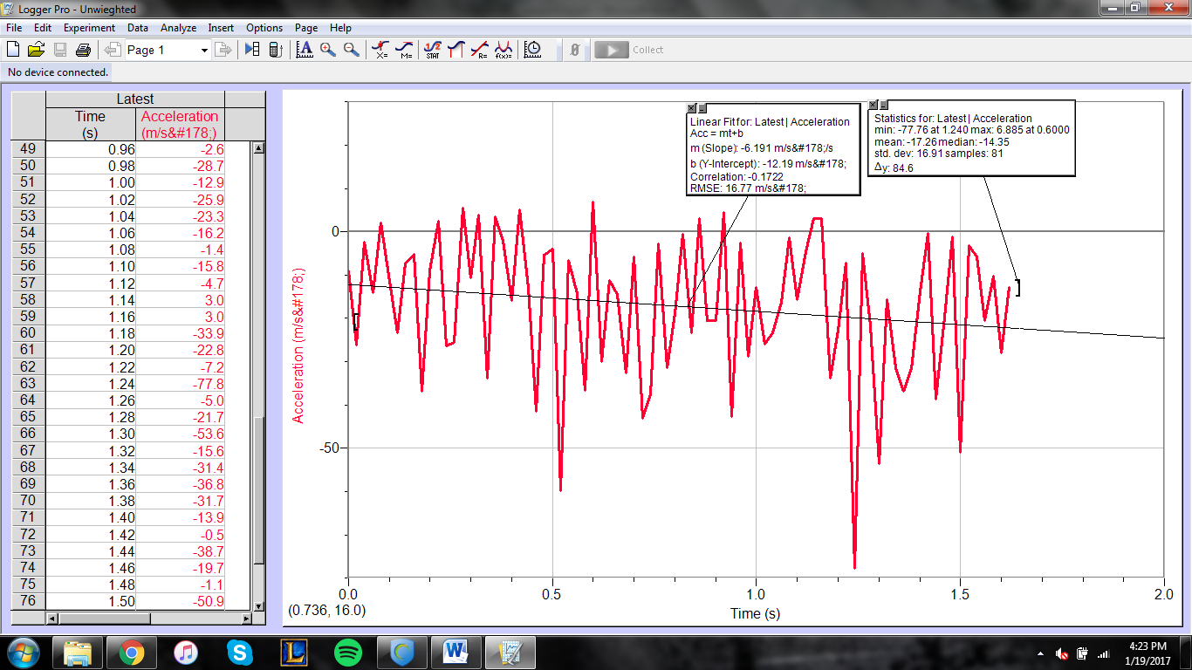
- This is a trail of the car with the accelerometer.
- As shown in the statistics of the acceleration graph the maximum acceleration of the car was 6.885${m/s}^{2}$at 0.6000sec. The minimum acceleration that the car reached was 77.56${m/s}^{2}$ at 1.240sec.
- If you look at the acceleration graph you can see how the car went at a steady constant acceleration. The acceleration of the car steadily slowed down as time increased.
We wanted to do a trail with weights however it was harder to make the car move with the weights. Also the graph on the computer was not collecting the data correctly so we could not do the second trial with the car.

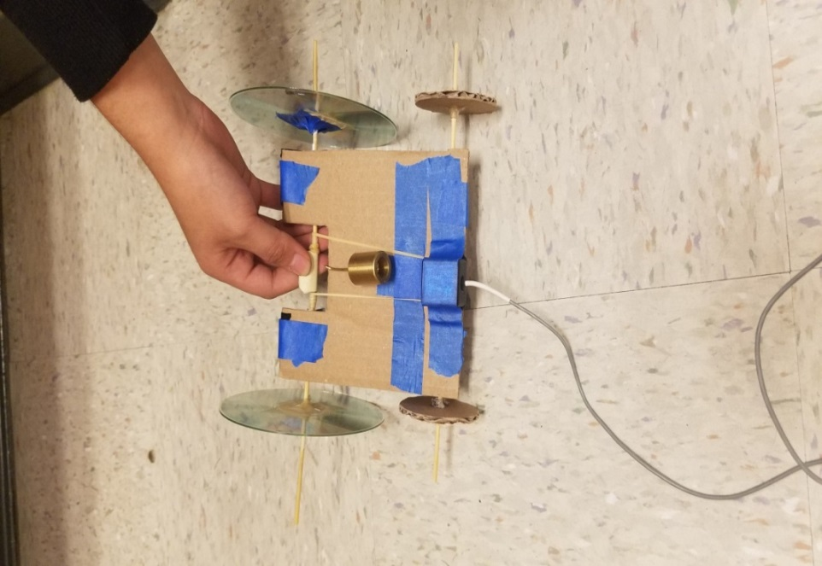
- To test the accelerometer on the car we had to tape the accelerometer to the front of the car, so it wouldn’t get in the way of anything. Then we held the cord as it moved so it could travel without any tension on the cord. The car was able to move freely and smoothly.

